V. Overall functionality of the VenDEX client

Assuming that DEX will be trading Cryptobonds in place of fiat currencies, vendors will need a software program called VenDEX (short for Vendors Distributed Exchange) to create, protect, and sell their product to people who buy their cryptobonds through DEX's Fiat Marketplace.

Like DEX, VenDEX will have a unique UserID and a simple GUI, with four menu options. Unlike DEX, it will not care about acceptable pingtime distances, nor even have a trading engine, despite having it's own separate marketplace.

When two vendors make a trade with VenDEX clients, they will find a middleman using DEX, and use that persons' client. (And pay them a fee too.) DEX Clients will know that incoming UserIDs from Vendors are not subject to acceptable pingtime, so any vendor in the world can trade cryptobonds with any other vendor in the world.

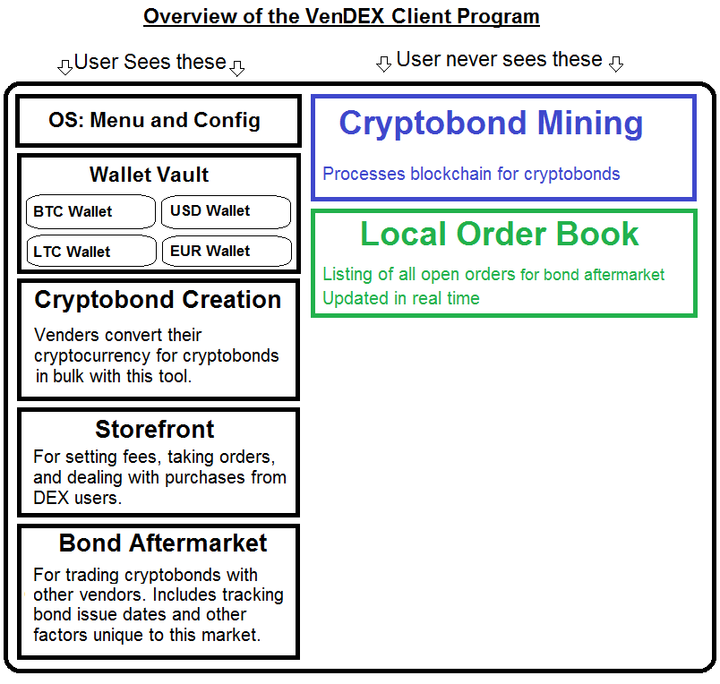
As you can see the functionality appears to be greater in VenDEX while there happens to be less coding involved, since we no longer have any graphing to do and are basically outsourcing the matching and escrow jobs of the aftermarket to existing DEX clients.

The four UI menu options on VenDEX are:

A. The Wallet Vault
Exactly like DEXs Wallet Vault, excepting that in each of the “fiat currency” wallets there is an additional breakdown screen allowing vendors to see more detail about each individual cryptobond and select or deselect it from any transfers. (So vendors can send particular bonds to particular users or other vendors.)

B. Cryptobond Creation
When it's time to create cryptobonds for any reason, this page facilitates creating batches of cryptobonds in the desired quantities, and sending the correct amount of the desired cryptocurrency into their wallets. When each bond is created, the correct “fiat currency” wallet is credited with all of the cryptobonds instantly, while all of the PGP Keys for those bonds are send to the Storefront, to be kept there as inventory.

C. Storefront
This multipurpose area inside VenDEX fulfills the purpose of trading Cryptobonds with DEX users by selling them and tracking their keys. It also has a settings panel for selecting their Fee and required fiat transfer options. After taking an order it tracks the order through completion and when it's time to redeem a cryptobond, it reverses the process too.

D. Bond Aftermarket
The final area inside VenDEX is an Over-The-Counter (OTC) style trading board, for vendors to trade cryptobonds and their keys amongst each other. They can use this market to speculate amongst each other on the future price of bitcoin, profit from each other's fiat needs, or just use it to get into or out of the vendor business altogether. Inside they can choose to buy or sell their cryptobonds to each other at a specified fee, with or without the keys for those cryptobonds, and with or without several other options too.

There is no graph nor real-time trading because very few items for trade will be similar. Each listing will have a lot of information about each cryptobond included, such as the rating of that vendor, if its' key is included, and the current amount of cryptocurrency inside taken directly from a 3rd-party service like blockchain.info.

A very important piece of information to go with each is if it is in a state of redemption currently, and if so, what are the fiat transfer requirements... Which allows a vendor who can pay the DEX customer in the proper fiat option to be able to buy and properly redeem the cryptobond.

In these cases, such as when a cryptobond's holder wants to redeem it but lives in a country that the original vendor cannot send Fiat to, the vendor must trade the bond through the bond aftermarket to another vendor who can fulfil the bondholder's needs.

Therefore the bond aftermarket must be robust enough to allow for limiting the scope of these trades between vendors to the payment option stated by the current bondholder... And do all of this quickly, so the bondholder can redeem in a couple of days or faster.

Despite the different format of trading board, all actual trading of cryptobonds is still done through the existing DEX framework with a middleman who takes a fee. (Which much be accounted for too, so it is yet another option that each bond for sale must identify.)

Note: Existing OTC boards like #bitcoin-otc should in theory be able to provide another channel for bond aftermarket trading. It would be less automated, but users of such OTC boards might prefer to do so.

Meanwhile, the suite of supporting applications 'under the hood' of the VenDEX client program represents much of the code. Those two modules are:

A. Cryptobond Mining
Mining cryptobonds is similar to mining bitcoins, in that every cryptobond is given a place on a distributed public ledger to stop double spending (copying) of cryptobonds in any way by any party.

However unlike bitcoin mining, cryptobonds are never worth more than about 1 Kuwaiti Dinar, which is currently the world's highest-valued currency worth $3.5 USD or just under 4 Bitcents. [source] More realistically, the British Pound, worth about $1.55 USD currently would be the largest currency likely traded as a cryptobond.

So if the payoff for hacking or copying a cryptobond is only going to gain the attacker a mere $1.55 maximum, then it's clear that bitcoins vast level of security through NSA-grade encryption is overkill for the job.

Therefore a lessor-grade encryption is called for, with shorter hashes and therefore a shorter blockchain that is indeed small enough for VenDEX clients to fulfill the role as Miners for the cryptobond distributed ledger network. Additionally, if there is a way to remove redeemed cryptobonds from the blockchain without sacrificing security, then doing so would be desirable for reasons of both speed and privacy.

Why VenDEX clients can run a whole Blockchain by themselves without mining nodes:

The blockchain transaction processing is a very important piece of this puzzle. Unlike bitcoin mining, this processing does not need large amounts of Hashing power because of three limitations:

A. The vendor only processes his own cryptobonds' ledger transactions... He doesn't have to worry about maintaining the whole blockchain, only his own sales to it.

B. The encryption used to secure cryptobonds need not be so strong as with cryptocurrencies, since each cryptobond only represents 1 unit of fiat. A smaller hash is therefore ideal, perhaps SHA 226 or something even smaller. (In comparisson, bitcoin uses SHA 256; one of the strongest encryptions available, meaning it requires a lot of CPU muscle to process.)

C. Once cryptobonds are Redeemed, they are removed from the blockchain! There is no point processing units that no long exist in any way. Who wants papertrails?

With these three haircuts, I'm convinced that all “Mining” of cryptobonds can be done on vendor clients alone without any dedicated mining rigs in the whole system like bitcoin requires. DEX clients won't have to mine a thing; it only needs to verify that the wallets do indeed have collateral in them by looking at the bitcoin blockchain.

B. Local Order Book
The smaller local order book for VenDEX only serves to host and share Bond Aftermarket trades, which are then aggregated and viewed in the bond aftermarket.

Like the order book in DEX, this one uses 'start' and 'stop' signals to maintain the book of trades from other vendors, but unlike the order book in DEX it only lists cryptobonds, although more information comes along with each one. Also, there are no limits to the degrees of separation between vendors... The goal is to trule offer the full, global volume in the bond aftermarket here.

It is basically a much smaller order book than DEX has with a lot more information shared about each trade. It automates some things that today's OTC market boards do manually, so it should still prove to speed up trading a noticeable amount from most OTC boards.

IV. Cryptobonds 101

It is simply not possible to actually export any kind of real fiat currency out of the bank-controlled systems and into a software like DEX. So to solve the rather heinous problem of properly representing fiat currencies inside it, a task which requires us to move units of stable value nearly effortlessly, we have to invent a whole new type of cryptosecurity. My humble suggestion for the role is called a cryptobond.

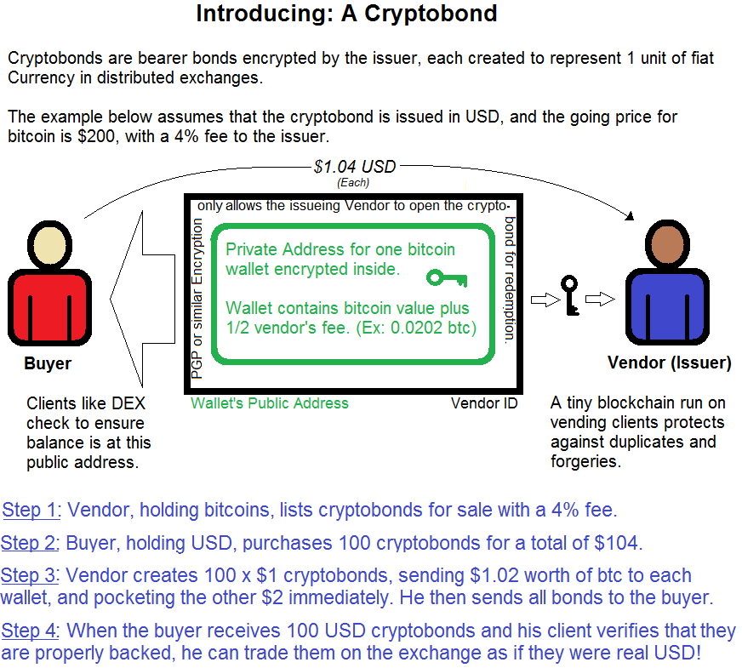

A cryptobond's worth is derived from the amount of bitcoin in its' own wallet
it has encrypted within it.

Like a bearer bond, a cryptobond will pay its' face value to the holder of that bond. So if you possess a $1 USD cryptobond, then it doesn't matter where it was issued, nor if it was issued yesterday or a decade ago... You can exchange it to the issuing vendor for $1 USD.
A cryptobond is not an a mere IOU though; each cryptobond is backed by collateral in the form of bitcoin, or whatever the most popular cryptocurrency of the day is. Like bitcoins, cryptobonds exist only as cryptographically secured placeholders, but unlike a bitcoin, a cryptobond has a real cryptocoin wallet inside of it that is redeemable for face value at the least!

For this bond to be a useful representation of fiat in DEX, it must be divisible to exactly the lowest denomination of the currency it represents, (1) and each one must be individually redeemable, since traders will be trading random numbers of them with other traders and not know how many they'll have to redeem at the end of the day.

Further, cryptobonds must exhibit all of the conditions of money if they are to be treated and thought of as money... Which means that they must be all of the following: Divisible, fungible, malleable, durable, scarce, & portable. For a real chance at success in this system however, it must be truly backed by something of steady worth, so the unit of cryptobond itself is seen as desirable. That's what will make a viable vendor business opportunity.

After much thought I'm convinced that a cryptobond offers the best available balance to all of these traits in a safe, ultra-portable new design... A collateral-backed, cryptographically-protected, distributed-ledger-tracked, bearer bond.

Lifecycle of a Cryptobond:

Let's say the buyer of a cryptobond, someone anywhere in the world who has a DEX client, opens his “Fiat Marketplace” panel and selects from the list of available vendors one with sufficient ratings and an acceptably low rate. The buyer then pays the vendor in real fiat, by whichever means of payment the two agree on, and the vendor uses his VenDEX software to create the cryptobonds for the buyer in a new wallet encrypted inside the bond.

The vendor holds the only encryption key to open the wallet, but for reasons we'll go into later, it is in his best interest to not do so until redemption by the new owner of the cryptobond. It is therefore relatively safe for the buyer to purchase these cryptobonds without a middleman or any type of escrow.

At the time of a $1 cryptobond's issuance, the price of bitcoin is taken from the regional aggregate exchange price (or otherwise agreed-upon price, such as MtGox) and one dollar's worth of bitcoin, along with ½ of the vendor's fee, is deposited (by the vendor) into a wallet made exclusively for this purpose, then encrypted. The VenDEX software will create these in bulk very quickly, and properly fund them all too.

The vendor sends the buyer's cryptobonds to him and immediately the are seen in the buyer's wallet Vault under the appropriate currency. (100 cryptobonds of USD will be seen as $100 USD cash in DEX's vault.)

Only the vendor will be able to get the private key out of that bond, ever, but while it's “live” it can be traded around the DEX network infinitely, and being tracked by a blockchain ledger (much like bitcoin's but smaller) to make sure there is no double spending.
Note: This process is very similar to “uploading your fiat” to an existing centralized exchange like MtGox from the point of view of a cryptocurrency purchaser... There is no way around the initial transfer time of the fiat currency, since that is a flaw in the world's banking system... But in both situations, once the wait for transferring the fiat money is done, your account is credited instantly with the proper amount of immediately-spendable fiat. (Which is exactly what cryptobonds will look like inside DEX.)

When the buyer wishes to use these USD cryptobonds inside DEX to purchase some other cryptocurrency or cryptosecurity, he treats them as real USD and during the trading Escrow process, the middleman doing the escrow additionally takes the action of checking blockchain.info to make sure that the incoming cryptobonds are still collateralized.

When the new owner of a cryptobond receives it, his DEX wallet will be credited with the same amount of the correct currency and of course his client software will start monitoring its' wallets on the blockchain to make sure the vendors holding the keys are honest.

This new buyer can hold onto it forever, or trade it away the next minute, without any thought about how old it is becoming... To DEX users, it simply is the currency it claims to be, and there will be no pressure on them to trade it sooner or later, despite what the vendors desire.

When it comes time for each cryptobond to be redeemed (for instance when someone holding a cryptocurrency bought it because he needed some real USD) he presses a button in his wallet vault to redeem them, and chooses the amount of them to redeem.

At that point the DEX client sends a redemption request signal to all the vendors holding those cryptobonds and the next time those vendors open up their VenDEX clients, they'll start the process of opening those and sending fiat to the redeemers at that time.

Once again, there will be a wait for the Fiat to be transferred by the agreed-upon means to this new holder of that bond. Additionally, if the vendor cannot access the fiat payment system of the new holder, there could be an additional wait while the vendor uses a vendor's market to trade that cryptobond to some other vendor who can.

Since those two vendors can trade fully in cryptocurrencies however, that additional wait will not require an additional fiat-transfer delay, adding only hours, not days to the overall redemption.

Cryptobond Safety:

There are two separate blockchains guaranteeing each cryptobond:

- The cryptocurrency that is held within the bond itself (bitcoin, for example) has its' own blockchain, and therefore the DEX client holding it can keep watching blockchain.info to make sure that the wallet has not been emptied. (Serving the Buyer)

- The VenDEX software, which made the cryptobond, has it's own vendor-shared, miniature blockchain for watching cryptobonds and guarding them from double spending. (Serving the Vendor)

Since each cryptobond is worth no more than 1 unit of its' currency, there need not be a strong level of encryption guarding the cryptobond blockchain, and therefore the vendor community doesn't need any “miners” to process the transactions... Since the CPU of each vendor's PC can handle this job easily.

To keep the vendor interested in redeeming the bond, the fee was split in half: ½ of the requested fee he took at creation, and the other ½ he (or the vendor he trades it to) gets at redemption.

So if he is selling 100 $1 USD bonds with an advertised fee of 4.00%, then he takes $104 fiat from the customer, pockets $2 fiat at the time of creation, sends the rest inside the cryptobond, (100 bonds with $1.02 worth of bitcoin inside them each) and those 100 bonds get mixed around cyberspace for who knows how long. Then at redemption, each of those bonds will be opened up, and the vendor wires the original fiat back to the user and pockets the remaining $2 worth of bitcoin.

There will be a vendors-only secondary market for trading cryptobonds between vendors inside the VenDEX software. As noted above, if the bondholder and vendor cannot transact fiat through a common system, this secondary market will allow the cryptobonds to be liquid enough so that they can trade them to another vendor who can transact properly.

Vendors may choose to trade ownership of cryptobonds here while the bond is still issued to a holder for that matter, since many different factors can make a cryptobond worth more or less to different vendors. This has the happy byproduct of creating a second financial market separate from DEX that will serve to make many people rich around the world.

Further, if the vendor quits the biz, he can always sell his VenDEX clientID to another vendor who can take his place and earn all those redemption fees.

Vendor penalty incentives:
The last thing a sane vendor would want to do is refuse to redeem a cryptobond. If he attempted to do so, he'd receive an automatic bad rating on his global profile across all DEX clients. He'd certainly have a hard time getting new customers in the future if the fiat marketplace of all DEX clients worldwide clearly displayed his actions in the ratings, per bond unredeemed.

It is true that a scammer could not care about redemption and just make lots of accounts for single use each, and it is also true that a vendor may just get lazy or stop caring about his business, so I've found a half dozen other incentives for him to want to redeem cryptobonds properly:

Seven reasons vendors will want to properly redeem cryptobonds:

- Their DEX vendor rating depend on every last bond being redeemed. And they're all only worth 1 unit of currency each! So in a down market, they'll even want to redeem a 'down' bond to protect their rating, ensuring that future bonds opportunities will be available to them.
- Reputation building will not be easy at the beginning. They'll likely have to prove themselves & start their ratings growth by offering extremely low rates and even asking people to help on 3rd-party forums like bitcointalk.org. They might have to even link their vendor account to other accounts online like their profile on facebook to show additional trust. (See BTCJam's verification system.)

- One half of their fee is inside, and is not touchable until redemption.

- If bitcoin is up; then it's an awesome gain for them. (And bitcoin is historically far more up than down!)

- Bonds are likely to be redeemed within hours or at least a few short days of purchase. (Meaning they'll still be present, and the price of BTC will still likely be the same.)

- Bonds can be sold to other vendors so if they're in need of fast cash, they'll be able to find it there instead of turning to theft.

- It's the easiest way for them to get bitcoin back to fund their next sale with.

As you can see, there are several strong incentives for vendors to always redeem them, even at a financial loss. Even still, there is no 100% guarantee, and a tiny percentage of the bonds may become non-redeemable.

In those cases, a cryptobond would simply become “decollateralized” or “dead,” and no other DEX clients will accept it. This prospect will of course cause fear in some people who have little trust ratings systems and community spirit... In those cases, their alternative will simply be to not use fiat on this exchange, only cryptocurrencies, which don't need the vendors. (And use centralized exchanges for fiat trades.)

Ultimately, it will be up to the free market to decide if this fiat-replacement model is what they want to trade on DEX.

One of DEXs key features is that it can be made to trade any fiat-replacement idea we can come up with, as long as they conform to criteria number 6 as laid out in part II. DEX can make any digital store of worth sliced into $1 increments into a tradeable $1.

